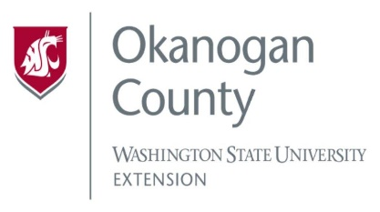
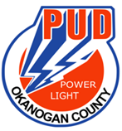
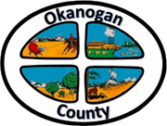
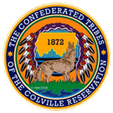

Meeting Minutes
OKANOGAN COUNTY & CCT
BROADBAND ACTION TEAM MEETING
August 25, 2022
2-3 pm

Meeting started: 2:00 PM
Introductions: Attendees by Zoom/call in:
Roni Holder-Diefenbach (Economic Alliance Executive Director), Kayla Wells-Yoakum (OK CO WSU Ext.), Kellie Conn (OK CO WSU Ext.), Edwardo Martinez (Spectrum), Scott Graham (CEO Three Rivers Hospital), Aaron Keester, Hanna Kliegman, Brandi Schwerdtfeger (ACRS), John MacDonald (PUD), Devin Gombosky (COM), Joanna Bastian (MethowNet), Kelly Hook, Chris St. Germaine (Ziply).
Devin Gombosky (COM) corrected minutes from the July 28th BAT meeting. Instead of ‘NOFO delayed until late 2023’ it is actually ‘late 2022’. The minutes where then approved.

Presenter for September 22nd meeting is Jenae Stark from CERB Community Economic Revitalization Board.
John McDonald (PUD)Grant Application Update-
- USDA Reconnect Round 3 application was disqualified for not having appropriate letters of endorsement from the CCT and overlapping service areas. Spoke with James Lightfoot (ACRS) and the intent is to resubmit amended Round 3 application during Round 4.
- The PUD will apply for the NTIA Middle Mile funding, 4 potential middle mile projects, will need letter of endorsement from WSBO broadband office. Devin Gombosky will assist with a letter of recommendation which will be signed by director Mark Moscone.
- Other upcoming funding opportunities are USDA Reconnect Round 4, and WSBO Infrastructure Acceleration Grant Round 2.
Roni Holder-Diefenbach (Economic Alliance Executive Director) Update-
- Spoke with Matthew Pleasants (CCT) and he hopes to be more active in participating at our BAT meetings.
- Read in the newspaper that PUD has done other BB improvement such as upgrading optical backbone from Pateros to Canada.
Brandi Schwerdtfeger (ACRS) Update-
- Biden-Harris Administration to Begin Accepting Applications on September 6 for USDA ReConnect Program Round 4 Funding.
https://www.federalregister.gov/documents/2022/08/04/2022-16694/rural-econnectivity-program
Devon Gombosky (COM) Update-
- Infrastructure Acceleration Grants have been placed on hold until the end of this year. Will release the NOFO in late 2022.
- Completed Digital Equity forum survey, waiting for results with a little over 2,000 Washington State residents participating.
- Closed the new round of Digital Navigator grants which were designed to be smaller community level grants that were aimed to be between $200-$500,000.
- COM is still experiencing staffing issues. Hiring a new Digital Equity Manager, should be filled in October. Devon is leaving the team to accept a new opportunity in Olympia.
- WSBO has completed an interagency agreement with Washington State University Extension to partner on BAT program development. Additional support resources should be coming from WSU.
Kayla Wells-Yoakum (WSU OK CO Ext.) Comment-
- Kayla shared this link to the article featured in their WSU Insider online newspaper. https://news.wsu.edu/press-release/2022/08/15/wsu-extension-dept-of-commerce-partner-to-expand-rural-broadband-access-equity/ Kayla was told that WSU will be reaching out to Extension directors to gauge interest and participation, she believes that the PI is Mike Gaffney, who is the director of the Community Economic Development Ext. unit.
Joanna Sebastian (MethowNet) Update-
- Broadband feasibility study is at the deciding phase, prioritizing, should know more soon.
Meeting adjourned at 2:34 pm. Next meeting is on September 22, 2022, at 2:00 pm.

Respectfully submitted by Kellie Conn, WSU Extension Okanogan County.

