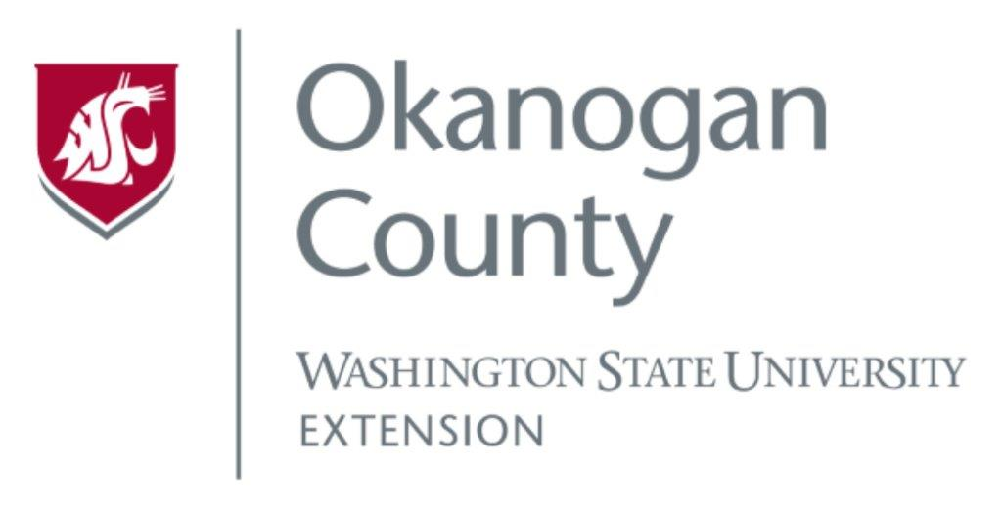
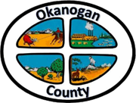
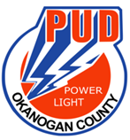
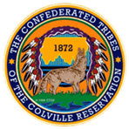

Okanogan County and CCT BAT Meeting
September 22, 2022
2-3:00pm

AGENDA

- Introductions-Please add your name/business in the chat

- Approve August 25th, Minutes, as emailed

- Grant Updates:

Presentation: Jenae Stark from CERB Community Economic Revitalization Board

