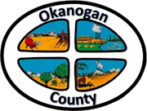
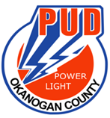
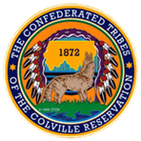

Okanogan County and CCT BAT Meeting
July 28, 2022
2-3:00pm

AGENDA

- Introductions-Please add your name/business in the chat

- Approve June 23, Minutes, as emailed

- Grant Updates:

- Presentation: Kim Herman, Partnership for Rural Washington

