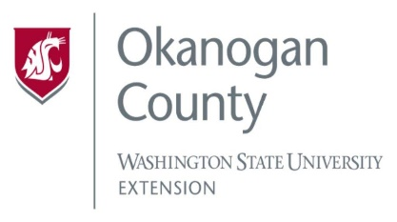
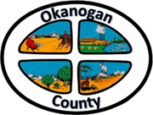
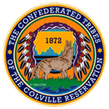

Meeting Minutes
OKANOGAN COUNTY & CCT
BROADBAND ACTION TEAM MEETING
May 26, 2022
2-3 pm

Meeting started: 2:00 PM
Introductions: Attendees by Zoom/call in:
Roni Holder-Diefenbach (Economic Alliance Executive Director), John McDonald (PUD), James Lightfoot (ACRS), Al Andy (COM), Chelsea Bagwell (COM), Greg Mendonca (OCEC), Joanna Bastian (Methow Net), Carlos Antuna (NVH IT), Kayla Wells-Yoakum (WSU OK CO), Brandi Schwerdtfeger (ACRS), Frederic Feit (Tilson), Michelle Gladstone-Wade (Commerce’s Tribal Liaison).
Minutes from the April 28th BAT meeting were approved.
Grant Updates-
John McDonald (PUD)-
- Attended a workshop for grant writing sponsored by the Washington State PUD Association.
- Working on NOFO for the NTIA Middle Mile grant program to identify builds that we could apply for.
- Waiting on June 9th release of WSBO Broadband Acceleration Grant, round 2.
- Waiting for NTIA Reconnect 4 to drop later this summer.
- PUD is continuing talks with Zipley regarding joint ventures into fiber infrastructure, ironing out details, more to follow. Asked if Zipley is open access network, yes, they claim to be, however their optical network is not mature enough in OK CO to start adopting customers, just now getting into the ‘staking phase’ of the build out into Brewster.
James Lightfoot (ACRS)-
- USDA Community Reconnect Grant, round 2 has received more applications compared to budgets, they are performing checks to see what is served or unserved and going through objection process.

Frederic Feit (Tilson)-
- NOFO for the IJB grant were released as well as the NOFO for Middle Mile project. Funding for Middle Mile is $1 B, will be very competitive.
- State has quite a lot of ARPA related funding which will be one or two additional rounds of spending.
- Broadband Equity, Access, and Deployment (BEAD) Program-critical rule making, learn more about the program. https://broadbandusa.ntia.doc.gov/resources/grant-programs/broadband-equity-access-and-deployment-bead-program

Roni Holder-Diefenbach (Economic Alliance Executive Director) –
- Met with USDA State Director, Roni stressed our concerns of rural and remote definition. On our last application we did not hit the maximum score for poverty, however the USDA recognizes our county as having a high poverty level. There are advocates at the state level that we can continue to work with to get us through the process.
- Spoke with Matthew from the CCT regarding the donation they received from one of their foundations, we will be receiving $5,000, working on a MOU for that donation.
- Reached out to Mark with the WSBO they are working on broadband action team support budget for next years budget, no details at this time. WSBO is aware of our CCT OK BAT and will move forward to assist us with our projects.
- CCT Bigfoot Communications hired their new director, office will be in Inchelium. They will provide retail broadband services to their members.
- Economic Alliance is partnering with the North Central Washington Tech Alliance to offer a cyber workshop in the Okanogan office. Check out their FB page to see who the presenters will be. Here is the link to register for the next cyber meet up: https://www.eventbrite.com/e/ncw-cyber-meetup-june-2022-tickets-343373688947

Joanna Bastian (MethowNet)
- Attended the ISP Focused Listening session. Covered feedback from last year and what they have improved on since then. Issues were insufficient time for material gathering and not enough clarity in the challenge process. Applicants must show reliable existing service and a plan to build out in the next 12 months.

Greg Mendonca (OCEC)
- Study is going well, nothing to share quite yet.

Al Andy (COM)
- Chelsea Bagwell created a PowerPoint presentation with everything that is happening with the Infrastructure Acceleration grants : Titled, Spring 2020 Funding Round Slide Deck, attached to email.
- New team member Devin Gombosky, COM 1.
  - Roni asked if the WSBO is sending out a monthly newsletter, once they have more staff that is the plan.
Michelle Gladstone (Commerce’s Tribal Liaison)
- Introduced herself and shared her background information. Will provide broadband information as it becomes available.

To view past minutes and agendas visit:
https://economic-alliance.com/about/broadband-action-meetings/
Meeting adjourned at 2:46 PM. Next meeting is June 23rd at 2:00 PM.
Respectfully submitted by Kellie Conn, WSU Extension Okanogan County.

