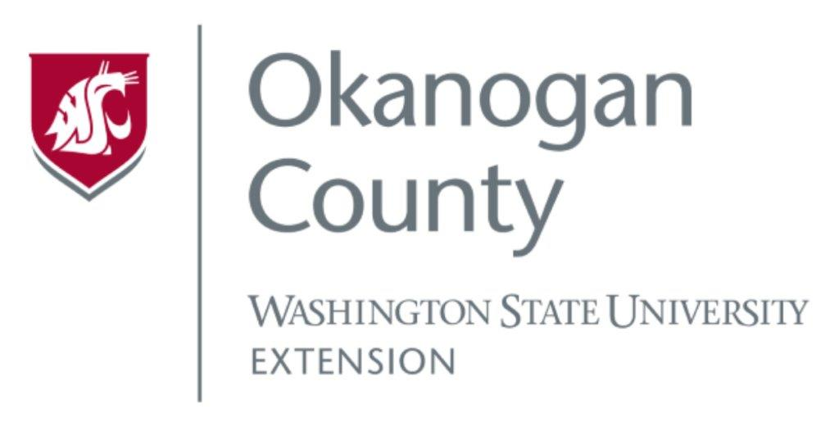
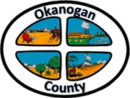
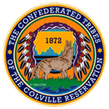

Okanogan County and CCT BAT Meeting
May 26, 2022
2-3:00pm

AGENDA

- Introductions-Please add your name/business in the chat

- Approve April 28th, Minutes, as emailed

- Grant Updates:

- Presentation: Michelle Gladstone-Wade, Tribal Liaison Director’s Office Washington State Dept. of Commerce 2:30 or 3:00 pm

