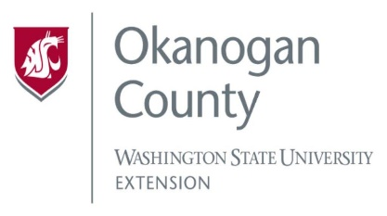
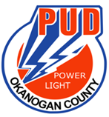
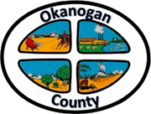
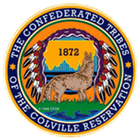

Meeting Minutes
OKANOGAN COUNTY & CCT
BROADBAND ACTION TEAM MEETING
March 24, 2021
2-3:30 pm

Meeting started: 2:00 PM
Introductions: Attendees by Zoom/call in:
Roni Holder-Diefenbach (Economic Alliance Executive Director), James Lightfoot (ACRS), Kayla Wells (OK CO WSU Ext.), John McDonald (PUD), Brandi Schwerdtfeger (ACRS), Chris S. Germaine (Zipley), Sarah Brown (TwispWorks), Al Andy (COM), Joanna Bastian (Methownet), Christopher Freel (Mid-Valley Hospital/Clinic), Frederic Feit (Tilson), Rachel McClure (Gov. Newhouse Office).
Minutes from the 24th BAT meeting were approved.
John McDonald PUD) Update- WSBO round 2 of the Infrastructure Acceleration grant which will be out mid-April offering a 90-day application window, we are looking at mid-July to apply. Our BAT is recognized by the WSBO as being very active which speaks well about our commitment to make sure OK CO is served.
James Lightfoot (ACRS) Update- Reached out to General Field Representative for RUS/Rural Utilities Service to see how many applications have been received, waiting to hear back. US Community Connect Grant program should be announced sometime in May, with a short window to apply. This grant is very critical for the areas we select, we should be discussing those criteria, or at least select our area. The US Community Connect grant would require a community type building in our proposed service area. We are working on pulling together a list of potential clubs, granges etc. to see if any of these will match the criteria.
Chris St. Germaine (Ripley) Update- Has not heard anything from WSBO related to the NTIA award. If awarded and the funding is received the requirement is one year to complete construction. Waiting for WSBO Infrastructure Accelerator opportunity. Contact Chris @ chris.stgermaine@zipley.com
Zipley website https://ziplyfiber.com/civicpartnerships
John McDonald and Christ St. Germaine will meet privately to discuss the Zipley/PUD partnership to provide broadband internet to Okanogan County.
Joanne Bastian (Methownet) Update- An article was published in the Methow Valley Newspaper about partnership between Methownet.com and OCEC. Ready to move forward.
Roni Holder-Diefenbach (Economic Alliance Executive Director) Update- Spoke with Matthew Pleasance (CCT), the tribe is currently working to get their services up and going, working to be their own retail service provider. Funding for our BAT will be running out in June, CCT received funding from a philanthropy organization to support BAT, Roni is working in a memorandum agreement with the tribe to access some of this money. Roni is always looking for funding and plans to support the BAT team and so will WSU. She spoke with the BOCC regarding ARPA funds to support BAT, they do not feel it is an eligible expense but will look at setting aside a percentage to match funds rather than setting aside money to support busy work. ARPA dollars need to be spent by 2026.
Frederic Feit (Tilson) Update- Discussed upcoming Federal and State Funding Programs. IIJA or The Bipartisan Infrastructure Bill was passed with 60 billion for infrastructure and digital equity broadband affordability programs. Funding will be administered by the WSBO.
ACP Affordable Conductivity Program replaces the EBB with 14 billion for funding.
ReConnect - Second round of funding sometime this year. https://www.rus-services.rd.usda.gov/s/

Al Andy (COM) Update-
- Speed test data. https://www.commerce.wa.gov/building-infrastructure/washington-statewide-broadband-act/speedtestsurvey/
- Infrastructure and acceleration grant cycle is coming up.
- Digital Equitable Forum is April 7th from 1-4 pm.
- Broadband Bipartisan Infrastructure law was passed and are waiting for rulemaking by the NCAA sometime mid-May.
- Equity and Affordability grants is 50 million mostly likely occurring in July of 2022.
- Mark Marsconi is named the new WSBO Director.
- Chelsea Bagwell is the new WSBO Infrastructure Specialist.
- Michelle Gladstone-Wade is WSBO Tribal Liaison.
Rachel McClure (Gov. Newhouse) Update- the Congressman co-sponsored HR 7060, which is the CONNECT unserved Americans act, this legislation will increase the unserved household threshold for the USDA reconnect Program. Has not been voted on yet, it has been proposed.
Meeting ended at 3:05 PM

To view past minutes and agendas visit:
https://economic-alliance.com/about/broadband-action-meetings/
Meeting adjourned at 2:56 PM. Next meeting is April 28th at 2:00 PM.
Respectfully submitted by Kellie Conn, WSU Extension Okanogan County.

