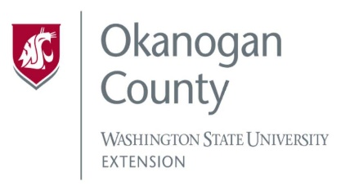
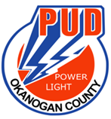
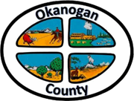
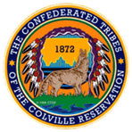

Meeting Minutes
OKANOGAN COUNTY & CCT
BROADBAND ACTION TEAM MEETING
February 24, 2021
2-3:30 pm

Meeting started: 2:00 PM
Introductions: Attendees by Zoom/call in:
Roni Holder-Diefenbach (Economic Alliance Executive Director), James Lightfoot (ACRS),Soo Ing-Moody (COM), Wendy Brzezny (North Central Accountable Community of Health), Sarah Brown (Twispworks), John McDonald (PUD), Brandi Schwerdtfeger (ACRS), Greg Mendonca (OK CO Electric Cooperative) Ron Gadeberg (OK PUD), Joanna Bastian (Methownet), Christopher Freel (Mid-Valley Hospital/Clinic), Rachel McClure (Congressman Dan Newhouse), Chris St. Germaine (Local Partnership Manager, Zipley Fiber), Al Andy (WSBO) Janet Warner, Kellie Conn (OK CO WSU) Harry Grant, Scott Graham (CEO Three Rivers Hospital), Matthew Pleasants (CCT), Hanna Kliegman.
John McDonald (PUD) – The PUD is in the process of completing the USDA Reconnect grant which is a 100% grant with without any matching components, as we qualify for the socially vulnerable. Deadline is March 9th to submit. If we are successful, we will see fiber to 2100 homes in the north part of Okanogan County.
The WSBO released a notice of funding opportunity last week for a pool of $19.1 M. However, it is for low interest loans.
Ron Gadeberg (PUD)- We had a few glitches with the online application, working on getting financial statements, forecast and data.
Matthew Pleasents (CCT)- The CCT is providing a letter of support to our BAT. CCT was awarded the Accelerator grant, where we will be working on a 2.5 tower in Nespelem WA. Keller Ferry location, Twin Lakes and Sugarloaf which will serve 25 homes, communication services will use that tower as well. Finishing the half mile on HWY 155 which will run the main fiber line to the tower, waiting on speed tests. Waiting to hear from NTIA with our ask being $43 M. It will take $93 M to service the rest of the Colville Reservation. If we are awarded there will be additional towers being built in the county further into East Omak and then South down to Kartar.
CCT are starting their own telecommunications and are advertising for this position as well as Board of Directors positions to be posted next week.
Roni Holder-Diefenbach Update- Met with general manager of OK CO-OP. They are updating a new strategic plan for their service territory which should be done in the next couple of months, this is a new plan independent of the Methow BAT. Interested in collaborating with our CCT OK CO BAT to look at funding opportunities they may be eligible for, will be interesting to see what they bring to the table.
Roni spoke with our 7th district representatives: Shelly Short, Joe Kretz, Jacquelin Maycumber, Dan Newhouse, and Senator Patty Murry who are all sending letters of support. Board of County Commissioners will send a LOS next week, as will Matthew Pleasants.
Chris St. Germaine (Zipley Fiber)-We received a message from WSBO asking for additional information for our NTIA application that included Loomis into Tonasket. Within the next few weeks WSBO will have an award announcement.
John McDonald would like to have a conversation with Zipley and Ron Gadeberg to see how we can collaborate in areas where we have overlap of the private infrastructure and public infrastructure. Instead of duplicating efforts we could strive to figure out how to use a single infrastructure.
Continued discussion of upcoming funding.
Al Andy (WSBO) Update- Feels that collaboration is an amazing approach, the entire goal is to connect all of Washington unserved communities.
- WSBO would like to know how to support BAT. WSBO would like more speed test data.
- Infrastructure and Acceleration grants have been funded and awarded to 14 counties for $145 M this first round.
- The first meeting for the Digital Equity Forum was held in December and the next will be on April 7th.
- Digital Navigator grant program, 4 grantees who are building out programs, purchasing equipment and hiring navigators’ hotlines, are to go live mid-February 2022.
- Noah Net equity and affordability grants $5M for maintenance and additions to Wi-Fi Hotspots, likely in July of this year.
- New WSBO Deputy is Erica Henry.
Matthew Pleasants – Understanding of community and the needed projects is what helped us to be awarded. For the CCT it is a process of building up to the capacity, some of our infrastructure is outdated so the first step is improving infrastructure.
AL suggested to be on COM list serv window@commerce.one.gov
Roni- Being Autumn with WSBO committed to sending us updated information such as survey results on a monthly basis, Roni is wondering why this is not happening? Al shared with us that WSBO does not have the personnel and are looking to hire someone for this role. We too would like to have accurate data to better serve our communities.
Looking at the survey map we have 2262 homes who have responded. We believe there are many more and need to have a larger pushing on social media, community groups such as churches, libraries, and hobby clubs. More letters of support are needed.
Meeting ended at 2:54 pm.

To view past minutes and agendas visit:
https://economic-alliance.com/about/broadband-action-meetings/
Meeting adjourned at 2:56 PM. Next meeting is March 24th at 2:00 PM.
Respectfully submitted by Kellie Conn, WSU Extension Okanogan County.

