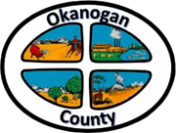
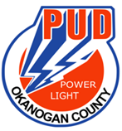
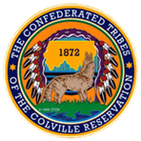

Okanogan County and CCT BAT Meeting
March 24, 2022
2-3:00pm

AGENDA

- Introductions-Please add your name/business in the chat

- Approve February 24th, Minutes, as emailed

- Grant Updates:

- Applications In: New Opportunities coming up

- Potential Funding to support BAT

