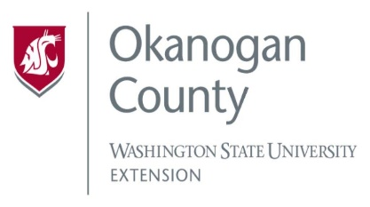
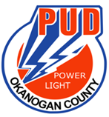
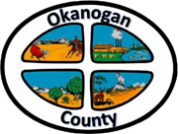
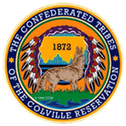

Meeting Minutes
OKANOGAN COUNTY & CCT
BROADBAND ACTION TEAM MEETING
January 27, 2021
2-3:30 pm

Meeting started: 2:00 PM
Introductions: Attendees by Zoom/call in:
Roni Holder-Diefenbach (Economic Alliance Executive Director), Soo Ing-Moody (COM), Wendy Brzezny (North Central Accountable Community of Health), Sarah Brow (Twispworks), John Mcdonald (PUD), Brandi Schwerdtfeger (ACRS), Greg Mendonca (OK CO Electric Cooperative) Ron Gadeberg (OK PUD), Joanna Bastian (Methownet), Christopher Freel (Mid-Valley Hospital/Clinic), Rachel McClure (Congressman Dan Newhouse), Chris St. Germaine (Local Partnership Manager, Zipley Fiber), Al Andy (WSBO) Janet Warner, Kellie Conn (OK CO WSU).

Approval of Dec. 30th minutes.

Wendy Brzezny, North Central Accountable Community of Health, Presentation- Wendy explained how her organization is designed to transform Medicaid by improving patients experience of care. They do this through education. She discussed barriers such as Technology, Privacy, and lack of Broadband.
Would like to have dedicated space such as a Kiosk for community members to access telehealth appointments easily via schools, library, and community centers.

Old Business: John MacDonald (PUD) updated us on the WSBO rounds of Accelerator Grant funding which the PUD applied for, unfortunately we were not awarded funding for the first round. Had a debrief with WSBO and was assured there would be another round of funding hopefully in the spring. Being our score came in at 131 out of 303 John asked the WSBO about the scoring metrics so we can focus our efforts and craft the best application moving forward.

Reconnect Grant -John and his team have been working on identifying project areas so we can apply for the USDA Reconnect grant program, this would be for Northern Okanogan Valley in the Palmer Lake, Oroville, and Chesaw areas. We are requesting $15 M, for 1000 households. The application is due Feb 22.

Brandi Schwerdtfeger (ACRS)- shared her map of these Reconnect grant areas and discussed scoring. We have a good chance of receiving funding.

Greg Mondoza (OCC) would like to know how he can get the same type of assistance for valid projects at Okanogan County Electric Coop.

- Roni Holder-Diefenbach -The Methow Valley BAT who is now with us, hired the consulting firm Tilson, Roni suggested to look at those results. Of course, Letters of Support (LOS) and funding to hire a consulting firm. We should all work together so we know who is submitting applications and for what areas.

Greg also mentioned the release of a survey for the electric membership, would like to get a Broadband feasibility study for the Methow area. 8-12 weeks for feasibility study, would like to partner with MethowNet.

Roni Holder-Diefenbach- Met with WSBO to discuss the criteria to apply for grants, listened to our needs and will try to do a better job. Colville Confederated Tribe, who is a part of our BAT, were awarded 4 million for their project. They do have other applications in the process as well. They were not able to attend the last couple BAT meetings to explain how the funding will be used.

Met with the Board of County Commissioners (BOCC), they asked Roni to follow up on projects that could be eligible for the ARP dollars and are looking at matching funding for Broadband.

Soo Ing-Moody- Discussed her new role as liaison with the Washington State Dept. Of Commerce. She has had recent conversations with the Dept. of Commerce about issues of competitiveness for areas such as ours. Believes that collaborating will be very helpful. There may be commerce programs to assist our broadband project and would like folks to contact her @ soo.ing-moody@commerce.wa.gov.

Chris St. Germaine (Zipley Fiber)- Zipley would like to be a part of our BAT. Chris has read past team minutes and has reviewed maps. Feels it will be a good collaboration to build partnerships to deploy fiber to the premise across our rural areas.

Al Andy (WSBO) Bullet Update-

- The Infrastructure and Acceleration grants have been awarded for the fall cycle.
- Digital Equity Forum meeting was held in December 2021, the next meeting will be in March of 2022.
- Digital Navigator grant program. Four grantees building out programs, purchasing equipment, and hiring navigators, expected to go live in February.
- Equity and affordability grants 5 million likely in July.
- New broadband office deputy director is Erica Henry.

Roni thanked Andy for joining us and asked if the WSBO had the speed test results to show us what the percentage is and where we are seeing the results from. Andy explained that there is a digital equity side and the infrastructure acceleration grant side. He is part of the infrastructure side and is joining on behalf of the digital equity team, Andy will be sure to ask them to provide testing results to our BAT.

To view past minutes and agendas visit:
https://economic-alliance.com/about/broadband-action-meetings/
Meeting adjourned at 3:00 PM. Next meeting is February 24th at 2:00 PM.
Respectfully submitted by Kellie Conn, WSU Extension Okanogan County.

