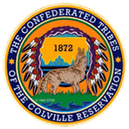

Okanogan County and CCT BAT Meeting
January 27, 2022
2-3:00pm

AGENDA

- Introductions-Please add your name/business in the chat

- Approve December 30th, Minutes, as emailed

- Presentation- Wendy Brzezny, NCACH’s Telehealth Initiative

- Old Business

- New Business

- Member Updates/Additions

