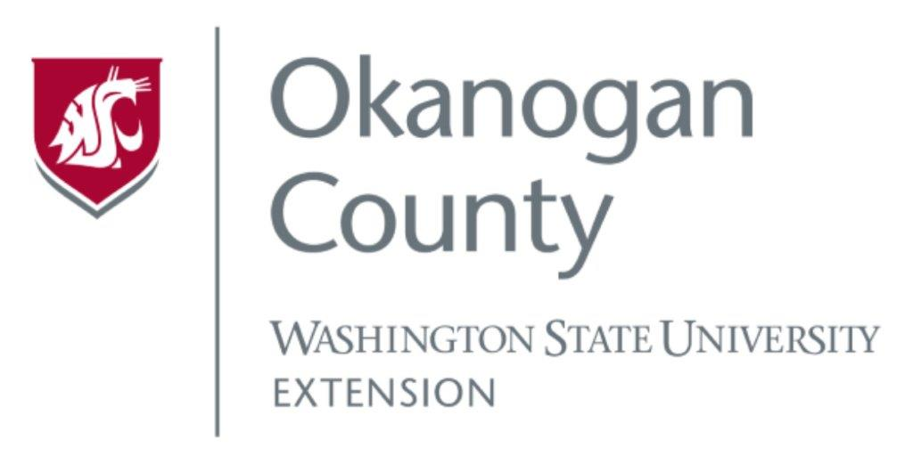
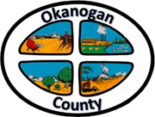
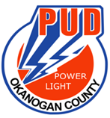
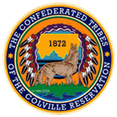

Okanogan County and CCT BAT Meeting
October 28, 2021
2-3:00pm

AGENDA

- Introductions-Please add your name/business in the chat

- Approve September 27, Minutes, as emailed

- USDA Grant Update-Broadband Study

- ACRS-James
- Roni

- Old Business
  - Tilson Presentation, Methow Valley BAT

- Member Updates/Additions
- Discussion November Meeting Date

