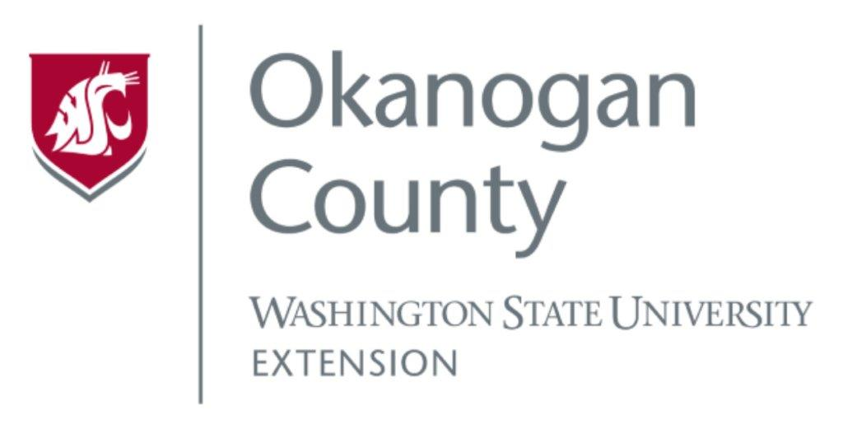
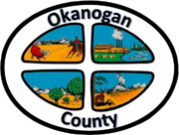
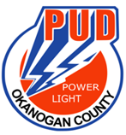
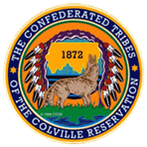

Okanogan County and CCT BAT Meeting
October 28, 2021
2-3:00pm

AGENDA

- Introductions-Please add your name/business in the chat

- Approve September 27, Minutes, as emailed

- USDA Grant Update-Broadband Study
ACRS-James
Roni

- Old Business
Methow Valley BAT Presenting

- New Business
WSBO Infrastructure Accelerator Grant Support Letters
Digital Navigator Grant- NCW Tech Alliance Application Information

- Member Updates/Additions
Discussion November Meeting Date

