
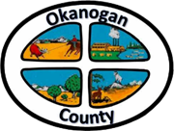
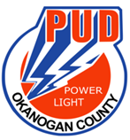
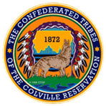

Okanogan County and CCT BAT Meeting
June 28, 2021
2-3:00pm

AGENDA

- Introductions-Please add your name/business in the chat

- Approve May 24, 2021 Minutes, as emailed

- Presentation:

- New Business: Roni grant update; ARPA Funds and USDA Grant.

- Old Business:

- Member Updates/Additions

Next Meeting Date is July 26 @ 2 pm.

Adjourn

