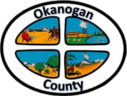
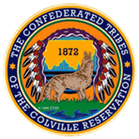

Okanogan County and CCT BAT Meeting
April 26, 2021
2-3:00pm

AGENDA

- Introductions-Please add your name/business in the chat
- Approve April 22nd Minutes, as emailed
- Presentation:
- Michael Porter Omak School District K-12

- New Business
- Projects and Grants Update (State Broadband Office)
- Monica Babine-NCACH Project and Remote Worker Training

- Old Business

- Member Updates/Additions
- PUD Update (John McDonald)
- WSU Extension Update (Monica Babine)
- CCT Update (Matthew Pleasants)
Next Meeting Date is May 24th @ 2 pm.

Adjourn

